Use GLFW, which is a lightweight library to help us create a window that can cross-platform. If we use win32 to create the window, we wouldn’t able to use it in Mac.

Download GFLW in www.glfw.org

We download the binaries version. Source package is more flexible for us to build a game engine, but we don’t need to go further on that. How to choose the version? It’s dependent on your application, whether you want it run on 32-bit or 64-bit CPU

You will get something like this:

Create an empty project for Visual Studio

Copy the document from glfw

We only use glfw3.lib, which is static link not dll

Create a dependency folder:

Drag the dependencies to this foler:

In VS, make sure is all configurations:

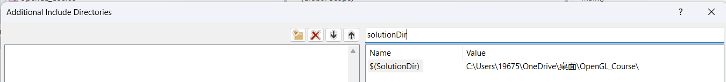

In linker:

In Input:

Now you must make sure that your download version (x64 or x86) of GLFW must be the same with the mode you select

Now we need to link to OpenGL function library

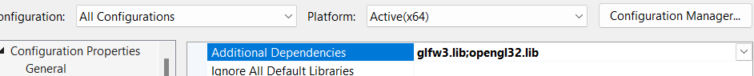

Each time when we find that unresolved external symbol, that means we lack of .lib file, and we check on Google, and add it on the dependencies:



finally

Now we get it

We use OpenGL legacy to try to draw a triangle, instead of shader program

